WEEK 1

AIMEN HASHMI

UI/UX

COSMICODE

Research and summarize the fundamentals of UI/UX design**.**

**What is UI/UX Design?**

* **UI (User Interface) Design focuses on how a product looks — colors, typography, buttons, layouts, etc.**
* **UX (User Experience) Design focuses on how a product works — how users interact with it, how easy and satisfying it is to use.**

**Core Fundamentals of UI/UX Design**

**1. User-Centered Design (UCD)**

**Design everything with the user in mind. Understand their needs, problems, goals, and behaviors through research.**

**Example: A food delivery app should prioritize ease of ordering over fancy animations.**

**2. Usability**

**The product should be:**

* **Easy to learn**
* **Efficient to use**
* **Error-tolerant**
* **Satisfying**

**Ask: Can users complete tasks without confusion or frustration?**

**3. Wireframing & Prototyping**

* **Wireframe = basic layout or blueprint (black and white, no design)**
* **Prototype = clickable version to simulate interactions**

**These help plan structure and flow before designing visuals.**

**4. Visual Hierarchy**

**Guide users’ eyes using:**

* **Font sizes and weights**
* **Color contrast**
* **Spacing**
* **Alignment**

**Important elements (like "Sign Up") should be clearly visible and easy to find.**

**5. Consistency**

**Use:**

* **Same color scheme**
* **Same button styles**
* **Same icons across all screens**

**This builds trust and reduces the learning curve.**

**6. Responsive Design**

**Design should work across:**

* **Desktops**
* **Tablets**
* **Phones**

**Layouts must adjust smoothly across screen sizes.**

**7. Accessibility**

**Make design usable for everyone, including people with disabilities:**

* **Add alt text to images**
* **Use readable fonts**
* **Ensure color contrast for vision-impaired users**

**8. Information Architecture (IA)**

**Organize and label content in a logical way:**

* **Menus**
* **Categories**
* **Navigation**

**Good IA = users find what they’re looking for without getting lost.**

**9. Interaction Design**

**Focus on how users interact:**

* **Buttons, sliders, gestures**
* **Microinteractions (like a button changing when clicked)**
* **Feedback (e.g., “Success!” after submitting a form)**

**10. UX Writing**

**The text in your app should be:**

* **Clear**
* **Concise**
* **Helpful**

**Replace “Error 438” with “Couldn’t connect to the internet. Try again?”**

Conduct user research and create user personas.

**PERSONA 1:**

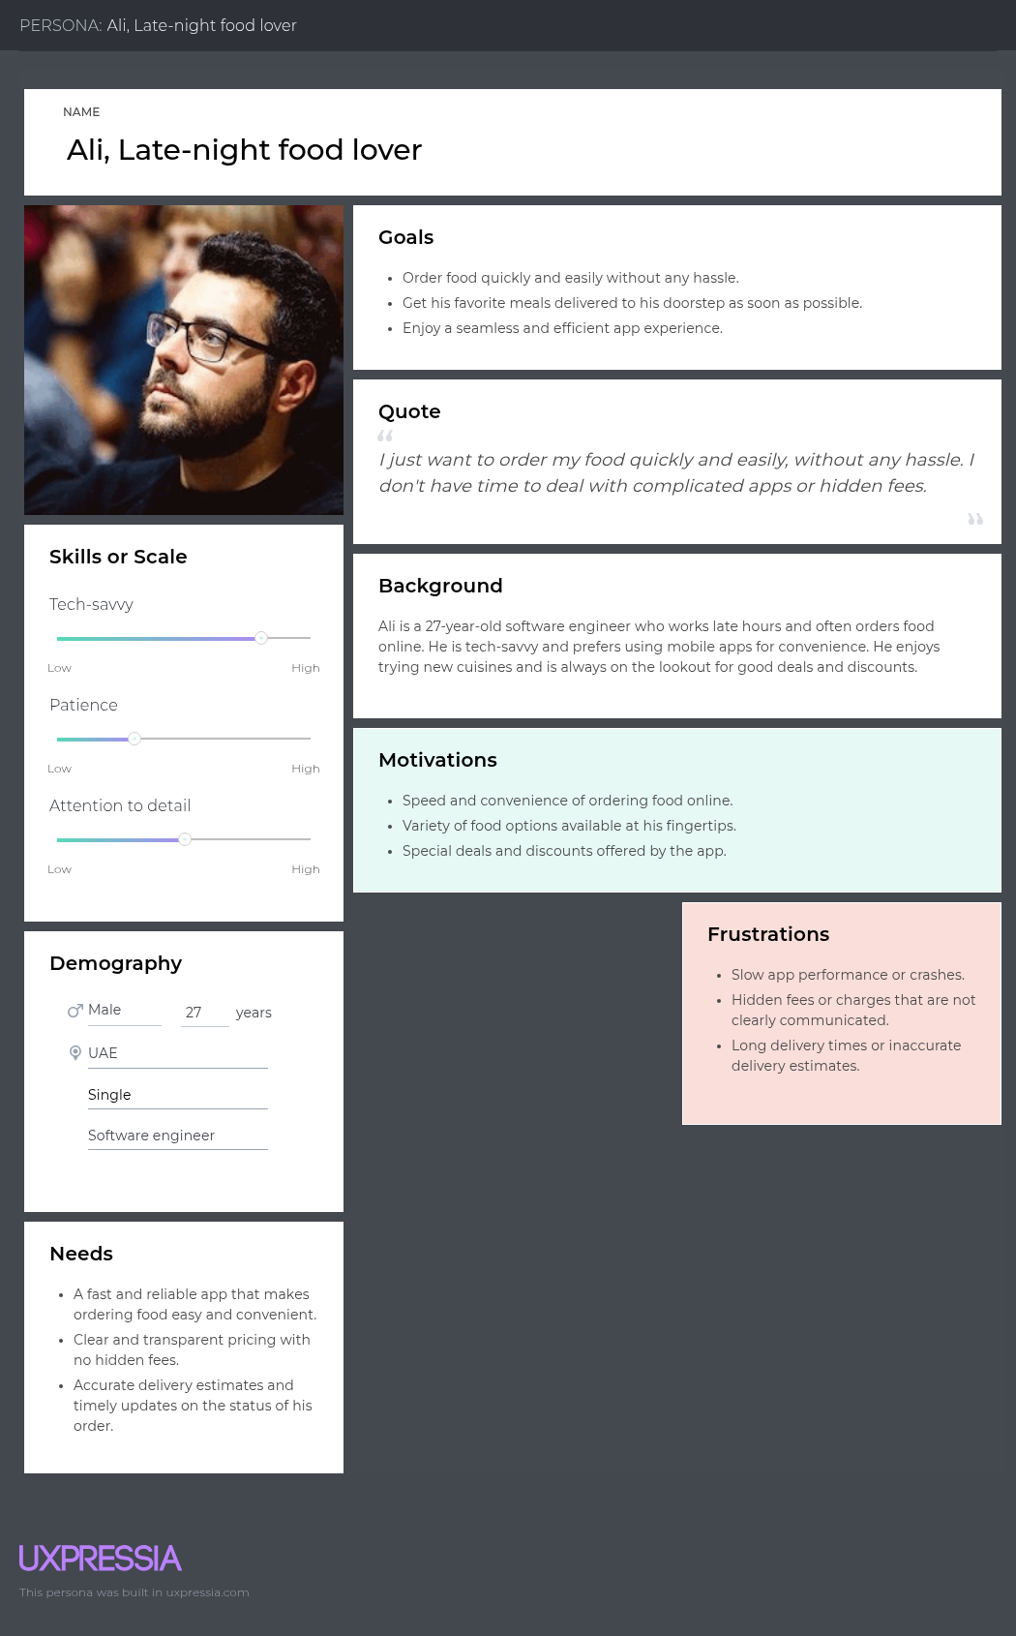

**PERSONA 2**

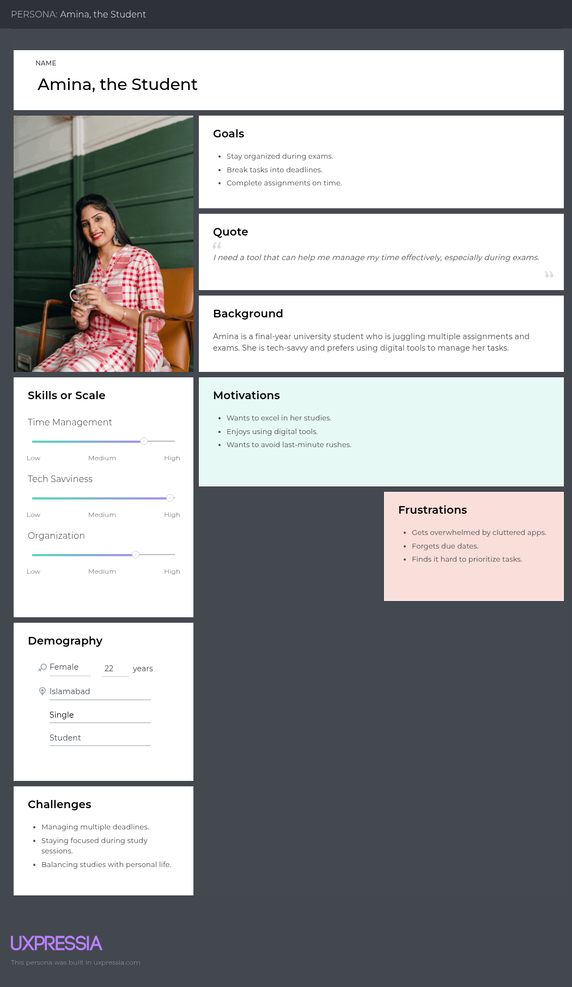

**PERSONA 3**

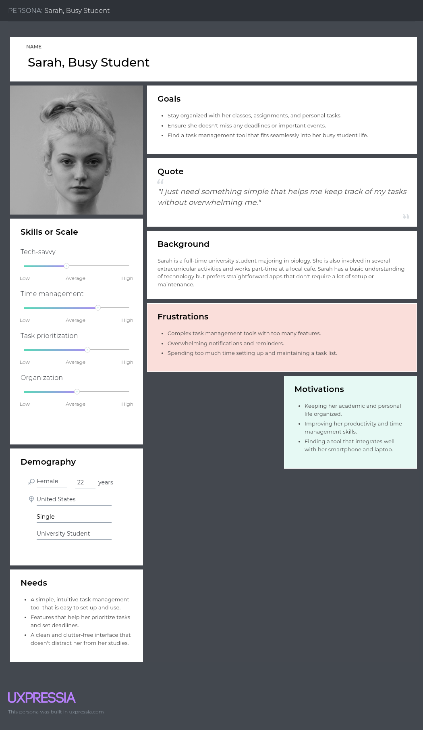

WIREFRAMES

**USING BALASAMIQ**

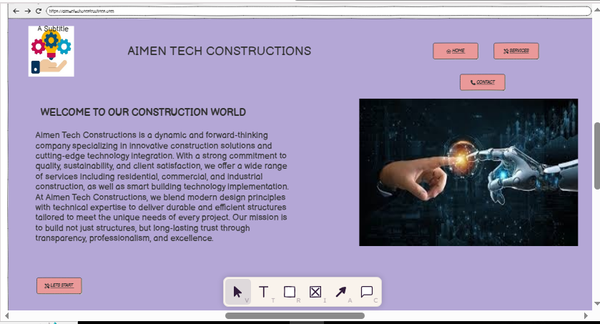

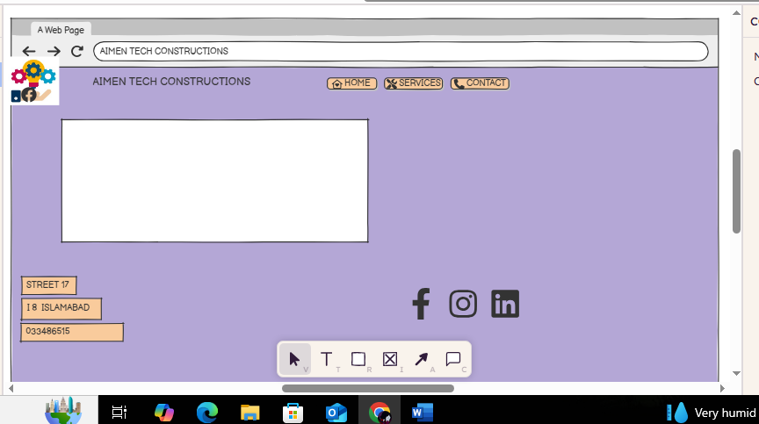

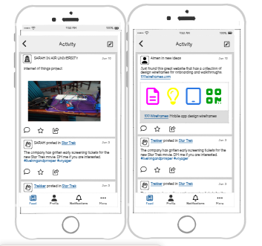

MOOD BOARD



**END OF DOCUMENT**